**Malachi — What Is The Danger Of Spiritual Apathy?**

January 12, 2025

* 1. Background
  2. When was Malachi written? — 420 BC
  3. Who was the author?

The oracle of the word of the LORD to Israel by Malachi. Malachi 1:1 (ESV)

* 1. What was wrong?
     1. The people had become apathetic about God.
     2. The people were inviting God’s judgment.

From the days of your fathers you have turned aside from my statutes and have not kept them. Return to me, and I will return to you, says the LORD of hosts… Malachi 3:7 (ESV)

“A son honors his father, and a servant his master. If then I am a father, where is my honor? And if I am a master, where is my fear? says the LORD of hosts…” Malachi 1:6 (ESV)

“And now, O priests, this command is for you. If you will not listen, if you will not take it to heart to give honor to my name, says the LORD of hosts, then I will send the curse upon you and I will curse your blessings… Malachi 2:1–2 (ESV)

When a man’s folly brings his way to ruin, his heart rages against the LORD. Proverbs 19:3 (ESV)

* 1. How is Malachi structured?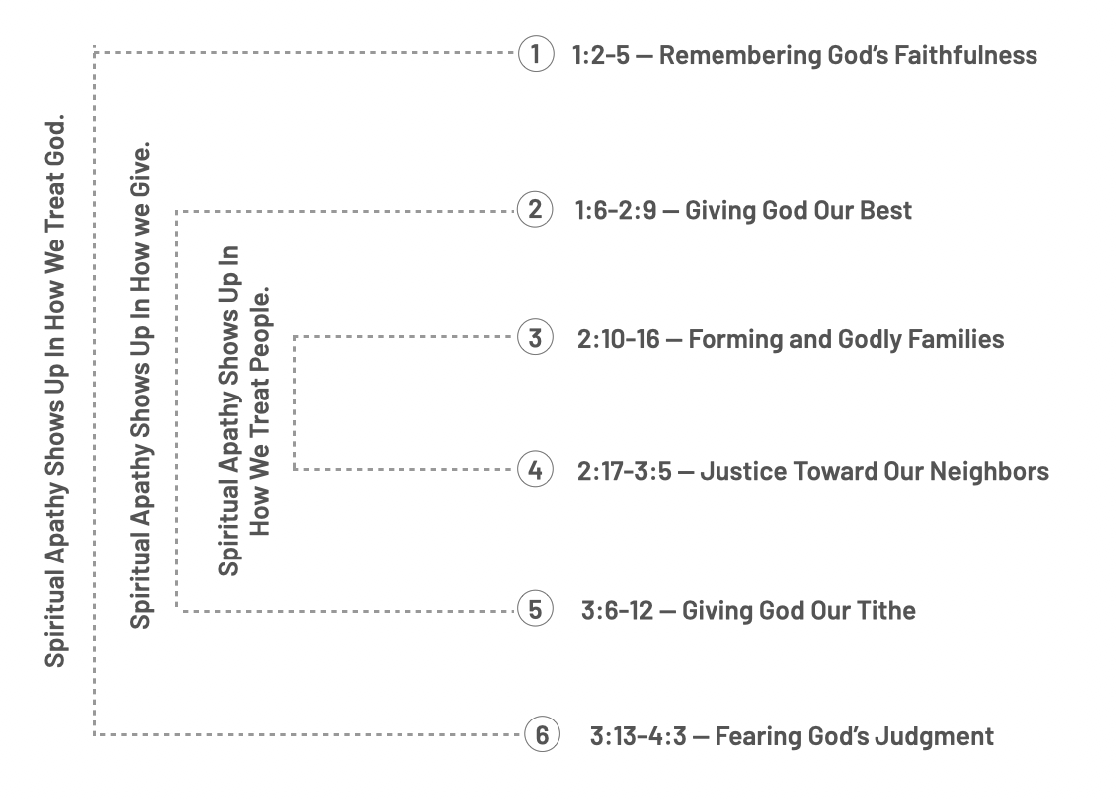
  2. Spiritual apathy shows up in how we treat people.
  3. True worship means forming and keeping godly families.

Have we not all one Father? Has not one God created us? Why then are we faithless to one another, profaning the covenant of our fathers? Judah has been faithless, and abomination has been committed in Israel and in Jerusalem. For Judah has profaned the sanctuary of the LORD, which he loves, and has married the daughter of a foreign god. May the LORD cut off from the tents of Jacob any descendant of the man who does this, who brings an offering to the LORD of hosts! Malachi 2:10–12 (ESV)

Do not be unequally yoked with unbelievers. For what partnership has righteousness with lawlessness? Or what fellowship has light with darkness?   
2 Corinthians 6:14 (ESV)

And this second thing you do. You cover the LORD’s altar with tears, with weeping and groaning because he no longer regards the offering or accepts it with favor from your hand. But you say, “Why does he not?” Because the LORD was witness between you and the wife of your youth, to whom you have been faithless, though she is your companion and your wife by covenant. Did he not make them one, with a portion of the Spirit in their union? And what was the one God seeking? Godly offspring. So guard yourselves in your spirit, and let none of you be faithless to the wife of your youth. “For the man who does not love his wife but divorces her, says the LORD, the God of Israel, covers his garment with violence, says the LORD of hosts. So guard yourselves in your spirit, and do not be faithless.”   
Malachi 2:13–16 (ESV)

Likewise, husbands, live with your wives in an understanding way, showing honor to the woman as the weaker vessel, since they are heirs with you of the grace of life, so that your prayers may not be hindered. 1 Peter 3:7 (ESV)

* 1. True worship means treating our neighbors with justice.

You have wearied the LORD with your words. But you say, “How have we wearied him?” By saying, “Everyone who does evil is good in the sight of the LORD, and he delights in them.” Or by asking, “Where is the God of justice?”…“Then I will draw near to you for judgment. I will be a swift witness against the sorcerers, against the adulterers, against those who swear falsely, against those who oppress the hired worker in his wages, the widow and the fatherless, against those who thrust aside the sojourner, and do not fear me, says the LORD of hosts.   
Malachi 2:17–3:5 (ESV)

* 1. Spiritual apathy shows up in how we give.
  2. True worship means giving God our best.

“A son honors his father, and a servant his master. If then I am a father, where is my honor? And if I am a master, where is my fear? says the Lord of hosts to you, O priests, who despise my name. But you say, ‘How have we despised your name?’ By offering polluted food upon my altar. But you say, ‘How have we polluted you?’ By saying that the Lord’s table may be despised. When you offer blind animals in sacrifice, is that not evil? And when you offer those that are lame or sick, is that not evil? Present that to your governor; will he accept you or show you favor? says the Lord of hosts. And now entreat the favor of God, that he may be gracious to us. With such a gift from your hand, will he show favor to any of you? says the Lord of hosts. Oh that there were one among you who would shut the doors, that you might not kindle fire on my altar in vain! I have no pleasure in you, says the Lord of hosts, and I will not accept an offering from your hand. For from the rising of the sun to its setting my name will be great among the nations, and in every place incense will be offered to my name, and a pure offering. For my name will be great among the nations, says the Lord of hosts. Malachi 1:6–11 (ESV)

…not neglecting to meet together, as is the habit of some, but encouraging one another, and all the more as you see the Day drawing near. Hebrews 10:25 (ESV)

“And now, O priests, this command is for you… So shall you know that I have sent this command to you, that my covenant with Levi may stand, says the Lord of hosts. My covenant with him was one of life and peace, and I gave them to him. It was a covenant of fear, and he feared me. He stood in awe of my name. True instruction was in his mouth, and no wrong was found on his lips. He walked with me in peace and uprightness, and he turned many from iniquity. For the lips of a priest should guard knowledge, and people should seek instruction from his mouth, for he is the messenger of the Lord of hosts. But you have turned aside from the way. You have caused many to stumble by your instruction. You have corrupted the covenant of Levi, says the Lord of hosts, and so I make you despised and abased before all the people, inasmuch as you do not keep my ways but show partiality in your instruction.” Malachi 2:1–9 (ESV)

* 1. True worship means giving our tithe.

“For I the Lord do not change… Return to me, and I will return to you, says the Lord of hosts. But you say, ‘How shall we return?’ Will man rob God? Yet you are robbing me. But you say, ‘How have we robbed you?’ In your tithes and contributions. You are cursed with a curse, for you are robbing me, the whole nation of you. Bring the full tithe into the storehouse, that there may be food in my house. And thereby put me to the test, says the Lord of hosts, if I will not open the windows of heaven for you and pour down for you a blessing until there is no more need. Malachi 3:6–10 (ESV)

What is a tithe? — It is a Hebrew word that means a tenth.

Why do believers avoid tithing? — They don’t tithe because they don’t trust God to meet their needs.

What if I can’t afford to tithe? — When we tithe, God promises to meet our needs and bless our lives. The better question is, “Can I afford to not tithe?”

Isn’t tithing just in the Old Testament and for the Jews? — No. Tithing is mentioned in Genesis before the Jews and in the New Testament (Matthew 23). Tithing is a floor to start our giving, not to be a ceiling to stop our giving.

Doesn’t the New Testament talk about grace-giving? — Yes. 2 Corinthians 9 teaches that our giving to God should be an expression of our gratitude for the grace of God through Jesus. This means our financial giving should be cheerful, joyful, and proportional to our income, knowing God promises to meet the needs of those who give.

The point is this: whoever sows sparingly will also reap sparingly, and whoever sows bountifully will also reap bountifully. 2 Corinthians 9:6 (ESV)

And God is able to make all grace abound to you, so that having all sufficiency in all things at all times, you may abound in every good work. 2 Corinthians 9:8 (ESV)

Where should our tithe go? — The storehouse, the local church.

What is God’s tithing challenge? — God asked the Jews in Malachi’s day to test Him. Tithe and see how he would bless the financial worship of their lives. Malachi reminds us that God doesn’t change. God invites us to test him by tithing and watching how He meets our needs and blesses our lives. This challenge is open to us.

* + - * Will you take God’s tithing challenge?
      * Will you begin giving to your local church?
  1. Conclusion
     1. Spiritual apathy shows up in how we treat people.
        1. True worship involves forming and keeping godly families.

Christians must only date and marry someone of the opposite sex who is passionate about Jesus.

Christians are not to divorce because they fall out of love with their spouse.

* + - 1. True worship means treating our neighbors with justice.

Christians keep their word.

Christians treat their employees fairly.

Christians care about justice for orphans, widows, immigrants, and the oppressed.

* + 1. Spiritual apathy shows up in how we give.
       1. True worship means giving God our best, not the leftovers.
       2. True worship means giving our tithes, being blessed by God, and seeing Him provide for our needs.

Life Group Questions

1. Read Malachi 2:10-12. Why were they dating and marrying outside the faith? What are practical ways young adults can avoid poor dating and marriage decisions?
2. Read Malachi 2:13-16. Why were they divorcing their wives? What are the unseen consequences of divorce? In the Bible, is there a time when divorce is not demanded but allowed?
3. Read Malachi 2:17-3:5. Where is injustice found in the fabric of modern society? What can Christians do to alleviate it?
4. Read Malachi 1:6-11. True worship means giving God our best in worship. What does that look like on Sundays? During the week? In our private lives?