My Earthly Choices Make An Eternal Difference

August 27, 2017

  - Is there a difference in eternity if someone comes to Christ as a young person versus to a death-bed conversion as an old person?
  - If Jesus always forgives my sin, does it make a difference in eternity if I continue to sin?

The Great White Throne Judgment
Then I saw a great white throne and him who was seated on it. From his presence earth and sky fled away, and no place was found for them. And I saw the dead, great and small, standing before the throne, and books were opened. Then another book was opened, which is the book of life. And the dead were judged by what was written in the books, according to what they had done. Revelation 20:11–12 (ESV)
And no creature is hidden from his sight, but all are naked and exposed to the eyes of him to whom we must give account. Hebrews 4:13 (ESV)
…Then another book was opened, which is the book of life. And the dead were judged by what was written in the books, according to what they had done. And the sea gave up the dead who were in it, Death and Hades gave up the dead who were in them, and they were judged, each one of them, according to what they had done. Then Death and Hades were thrown into the lake of fire. This is the second death, the lake of fire. And if anyone’s name was not found written in the book of life, he was thrown into the lake of fire. Revelation 20:12–15 (ESV)
Yes, I ask you also, true companion, help these women, who have labored side by side with me in the gospel together with Clement and the rest of my fellow workers, whose names are in the book of life. Philippians 4:3 (ESV)
The Judgment Seat Of Christ
There is therefore now no condemnation for those who are in Christ Jesus. Romans 8:1 (ESV)
We are saved by grace but we are rewarded by works.
Watch yourselves, so that you may not lose what we have worked for, but may win a full reward. 2 John 8 (ESV)
I am coming soon. Hold fast what you have, so that no one may seize your crown. Revelation 3:11 (ESV)
“Behold, I am coming soon! My reward is with me, and I will give to everyone according to what he has done. Revelation 22:12 (NIV)
At the judgment seat of Christ, my life will be given a serious review.
For we must all appear before the judgment seat of Christ, so that each one may receive what is due for what he has done in the body, whether good or evil. 2 Corinthians 5:10 (ESV)
Do you not know that in a race all the runners run, but only one gets the prize? Run in such a way as to get the prize. Everyone who competes in the games goes into strict training. They do it to get a crown that will not last; but we do it to get a crown that will last forever. 1 Corinthians 9:24–25 (NIV84)
  - Christ will evaluate how we used our gifts and talents.
  - Christ will evaluate what we did with opportunities he provided.
For we are his workmanship, created in Christ Jesus for good works, which God prepared beforehand, that we should walk in them. Ephesians 2:10 (ESV)
  - Christ will evaluate how we handled temptation.
  - Christ will evaluate our thought life.
I the Lord search the heart and test the mind, to give every man according to his ways, according to the fruit of his deeds.” Jeremiah 17:10 (ESV)
Therefore do not pronounce judgment before the time, before the Lord comes, who will bring to light the things now hidden in darkness and will disclose the purposes of the heart. Then each one will receive his commendation from God. 1 Corinthians 4:5 (ESV)
  - Christ will evaluate our careless words.
I tell you, on the day of judgment people will give account for every careless word they speak, Matthew 12:36 (ESV)
  - Christ will evaluate the way we used our time.
Look carefully then how you walk, not as unwise but as wise, making the best use of the time, because the days are evil. Ephesians 5:15–16 (ESV)
  - Christ will evaluate graciously.
The prospect of eternal rewards are a legitimate reason to serve Christ.
(Moses) choosing rather to be mistreated with the people of God than to enjoy the fleeting pleasures of sin. He considered the reproach of Christ greater wealth than the treasures of Egypt, for he was looking to the reward. Hebrews 11:25–26 (ESV)
But love your enemies, and do good, and lend, expecting nothing in return, and your reward will be great,... Luke 6:35 (ESV)
What do God’s eternal rewards look like?
  - We will have crowns.
  - We will gain what we lost for the sake of Christ.
Jesus said to them, “Truly, I say to you, in the new world, when the Son of Man will sit on his glorious throne, you who have followed me will also sit on twelve thrones, judging the twelve tribes of Israel. And everyone who has left houses or brothers or sisters or father or mother or children or lands, for my name’s sake, will receive a hundredfold and will inherit eternal life. Matthew 19:28–29 (ESV)
  - We will obtain greater glory with Christ.
The Spirit himself bears witness to our spirit that we are Godʼs children. And if children, then heirs (namely, heirs of God and also fellow heirs with Christ) – if indeed we suffer with him so we may also be glorified with him. For I consider that our present sufferings cannot even be compared to the glory that will be revealed to us. Romans 8:16–18 (NET)
  - We will gain greater rulership from Christ.
The first came before him, saying, ‘Lord, your mina has made ten minas more.’ And he said to him, ‘Well done, good servant! Because you have been faithful in a very little, you shall have authority over ten cities.’ And the second came, saying, ‘Lord, your mina has made five minas.’ And he said to him, ‘And you are to be over five cities.’… ’I tell you that to everyone who has, more will be given, but from the one who has not, even what he has will be taken away. Luke 19:16-19, 26 (ESV)
How can I gain greater rewards?

  - Financial generosity in the name of Christ
“Do not lay up for yourselves treasures on earth, where moth and rust destroy and where thieves break in and steal, but lay up for yourselves treasures in heaven, where neither moth nor rust destroys and where thieves do not break in and steal. For where your treasure is, there your heart will be also. Matthew 6:19–21 (ESV)
  - Practical care for those in need
But when you give a feast, invite the poor, the crippled, the lame, the blind, and you will be blessed, because they cannot repay you. For you will be repaid at the resurrection of the just.” Luke 14:13–14 (ESV)
  - Joyful acceptance of God-ordained suffering
In this you rejoice, though now for a little while, if necessary, you have been grieved by various trials, so that the tested genuineness of your faith—more precious than gold that perishes though it is tested by fire—may be found to result in praise and glory and honor at the revelation of Jesus Christ. 1 Peter 1:6– 7 (ESV)
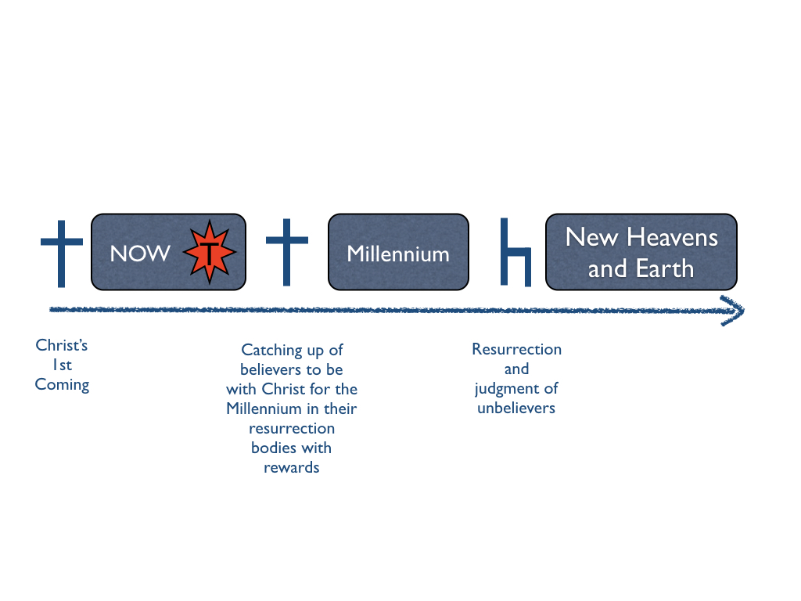
  - Hearty work in my vocation
Whatever you do, work heartily, as for the Lord and not for men, knowing that from the Lord you will receive the inheritance as your reward. You are serving the Lord Christ. Colossians 3:23–24 (ESV)
  - Every good thing we do
knowing that whatever good anyone does, this he will receive back from the Lord, whether he is a slave or free. Ephesians 6:8 (ESV)
Application
  - We are saved by grace, but we are rewarded by works.
  - The person we are today will determine the rewards we receive tomorrow.

