John 1:35-51 — Compelled To Recommend

The next day again John was standing with two of his disciples, and he looked at Jesus as he walked by and said, “Behold, the Lamb of God!” The two disciples heard him say this, and they followed Jesus. Jesus turned and saw them following and said to them, “What are you seeking?” And they said to him, “Rabbi” (which means Teacher), “where are you staying?” He said to them, “Come and you will see.” So they came and saw where he was staying, and they stayed with him that day, for it was about the tenth hour. One of the two who heard John speak and followed Jesus was Andrew, Simon Peter’s brother. He first found his own brother Simon and said to him, “We have found the Messiah” (which means Christ). He brought him to Jesus. Jesus looked at him and said, “You are Simon the son of John. You shall be called Cephas” (which means Peter). The next day Jesus decided to go to Galilee. He found Philip and said to him, “Follow me.” Now Philip was from Bethsaida, the city of Andrew and Peter. Philip found Nathanael and said to him, “We have found him of whom Moses in the Law and also the prophets wrote, Jesus of Nazareth, the son of Joseph.” Nathanael said to him, “Can anything good come out of Nazareth?” Philip said to him, “Come and see.” Jesus saw Nathanael coming toward him and said of him, “Behold, an Israelite indeed, in whom there is no deceit!” Nathanael said to him, “How do you know me?” Jesus answered him, “Before Philip called you, when you were under the fig tree, I saw you.” Nathanael answered him, “Rabbi, you are the Son of God! You are the King of Israel!” Jesus answered him, “Because I said to you, ‘I saw you under the fig tree,’ do you believe? You will see greater things than these.” And he said to him, “Truly, truly, I say to you, you will see heaven opened, and the angels of God ascending and descending on the Son of Man.” John 1:35–51 (ESV)

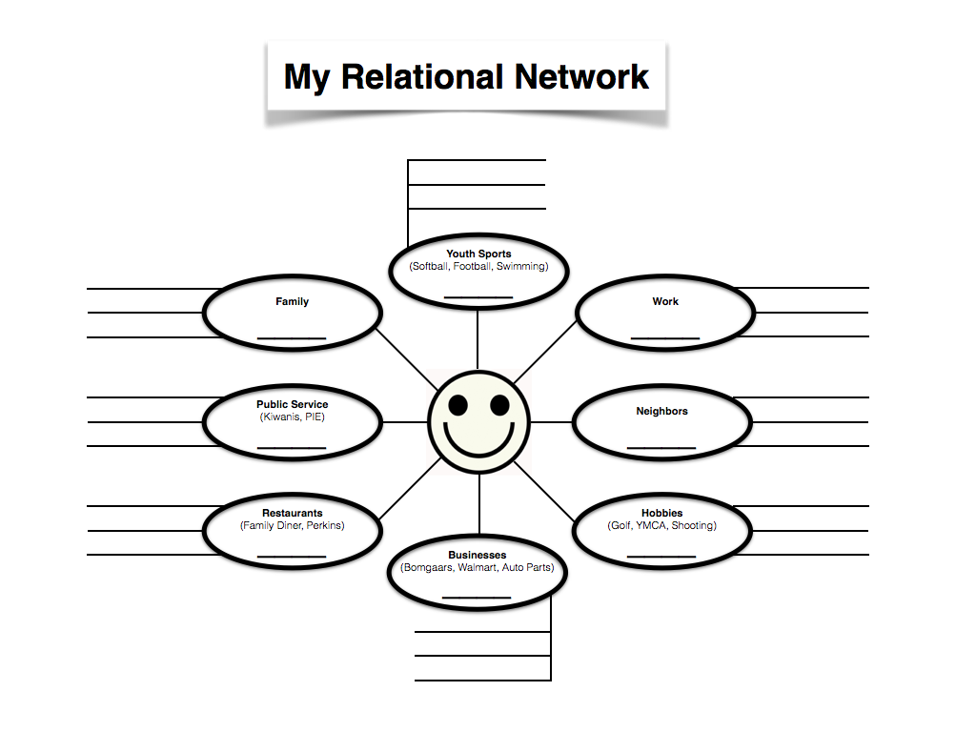
What is my relational network?

What made Hush Puppies famous?

My relational network has the power of geometric progression.

John 1:35-51
The disciples came to Jesus through their relational networks
1. Recommend Jesus to my acquaintances.
Andrew and John met Jesus through John the Baptist.
The next day again John was standing with two of his disciples, and he looked at Jesus as he walked by and said, “Behold, the Lamb of God!” John 1:35–36 (ESV)

Why did John the Baptist believe in Jesus?
And John bore witness: “I saw the Spirit descend from heaven like a dove, and it remained on him. I myself did not know him, but he who sent me to baptize with water said to me, ‘He on whom you see the Spirit descend and remain, this is he who baptizes with the Holy Spirit.’ And I have seen and have borne witness that this is the Son of God.” John 1:32–34 (ESV)

What does it mean to say “Jesus is the Lamb of God”?

Who were the two disciples?
The two disciples heard him say this, and they followed Jesus. John 1:37 (ESV)

Jesus turned and saw them following and said to them, “What are you seeking?” And they said to him, “Rabbi” (which means Teacher), “where are you staying?” He said to them, “Come and you will see.” So they came and saw where he was staying, and they stayed with him that day, for it was about the tenth hour. John 1:38–39 (ESV)

Why did they call Jesus Rabbi?

Don’t underestimate the power of recommending Jesus.

We don’t need to prove Jesus. Just let people spend time with him.

2. Recommend Jesus to my family.
Peter met Jesus through his brother Andrew.
One of the two who heard John speak and followed Jesus was Andrew, Simon Peter’s brother. He first found his own brother Simon and said to him, “We have found the Messiah” (which means Christ). He brought him to Jesus. Jesus looked at him and said, “You are Simon the son of John. You shall be called Cephas” (which means Peter). John 1:40–42 (ESV)

3. Recommend Jesus to my coworkers and neighbors.
Philip met Jesus through Andrew and Peter.
The next day Jesus decided to go to Galilee. He found Philip and said to him, “Follow me.” Now Philip was from Bethsaida, the city of Andrew and Peter. John 1:43–44 (ESV)

4. Recommend Jesus to my doubting friends.
Doubting Nathanael met Jesus through Philip.
Philip found Nathanael and said to him, “We have found him of whom Moses in the Law and also the prophets wrote, Jesus of Nazareth, the son of Joseph.” Nathanael said to him, “Can anything good come out of Nazareth?” Philip said to him, “Come and see.” John 1:45–46 (ESV)

Jesus saw Nathanael coming toward him and said of him, “Behold, an Israelite indeed, in whom there is no deceit!” Nathanael said to him, “How do you know me?” Jesus answered him, “Before Philip called you, when you were under the fig tree, I saw you.” Nathanael answered him, “Rabbi, you are the Son of God! You are the King of Israel!” John 1:47–49 (ESV)

How does the story of Jesus continue?
- My mission field is my relational network.
- Understand the simple process of coming to faith.
- Remember I don’t need to convince people about Jesus. I only need to invite them to meet him.

