Introduction to Genesis

- What is the problem with Theistic Evolution and the Day-Age theory?

- What is the problem with the Gap Theory?

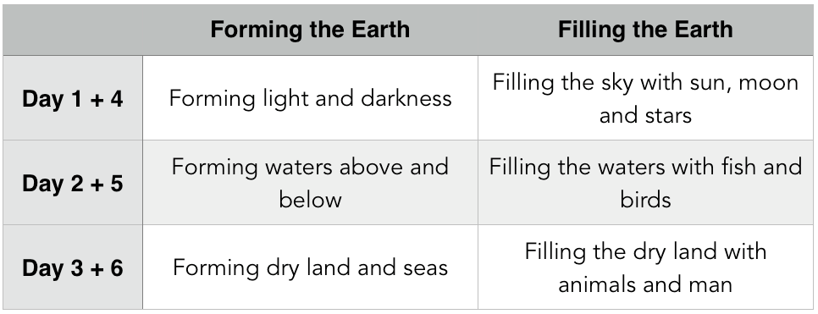
- What is the problem with time and chance producing evolution?

Day One — Forming Light and Darkness
The earth was without form and void, and darkness was over the face of the deep. And the Spirit of God was hovering over the face of the waters. And God said, “Let there be light,” and there was light. And God saw that the light was good. And God separated the light from the darkness. God called the light Day, and the darkness he called Night. And there was evening and there was morning, the first day. Genesis 1:2–5 (ESV)

When he established the heavens, I was there (speaking about Jesus); when he drew a circle on the face of the deep, Proverbs 8:27 (ESV)

who alone has immortality, who dwells in unapproachable light,… 1 Timothy 6:16 (ESV)

Day Two — Forming Waters Above and Below
And God said, “Let there be an expanse in the midst of the waters, and let it separate the waters from the waters.” And God made the expanse and separated the waters that were under the expanse from the waters that were above the expanse. And it was so. And God called the expanse Heaven. And there was evening and there was morning, the second day. Genesis 1:6–8 (ESV)

Day Three — Forming Dry Land and Seas
And God said, “Let the waters under the heavens be gathered together into one place, and let the dry land appear.” And it was so. God called the dry land Earth, and the waters that were gathered together he called Seas. And God saw that it was good. And God said, “Let the earth sprout vegetation, plants yielding seed, and fruit trees bearing fruit in which is their seed, each according to its kind, on the earth.” And it was so. The earth brought forth vegetation, plants yielding seed according to their own kinds, and trees bearing fruit in which is their seed, each according to its kind. And God saw that it was good. And there was evening and there was morning, the third day. Genesis 1:9–13 (ESV)

Day Four — Filling the Sky with the Sun, Moon and Stars
And God said, “Let there be lights in the expanse of the heavens to separate the day from the night. And let them be for signs and for seasons, and for days and years, and let them be lights in the expanse of the heavens to give light upon the earth.” And it was so. And God made the two great lights—the greater light to rule the day and the lesser light to rule the night—and the stars. And God set them in the expanse of the heavens to give light on the earth, to rule over the day and over the night, and to separate the light from the darkness. And God saw that it was good. And there was evening and there was morning, the fourth day. Genesis 1:14–19 (ESV)
Page 2

The heavens declare the glory of God, and the sky above proclaims his handiwork. Psalm 19:1 (ESV)

Day Five — Filling the Waters With Fish and Birds
And God said, “Let the waters swarm with swarms of living creatures, and let birds fly above the earth across the expanse of the heavens.” So God created the great sea creatures and every living creature that moves, with which the waters swarm, according to their kinds, and every winged bird according to its kind. And God saw that it was good. And God blessed them, saying, “Be fruitful and multiply and fill the waters in the seas, and let birds multiply on the earth.” And there was evening and there was morning, the fifth day. Genesis 1:20–23 (ESV)

Consider the amazing archer fish.

Consider the amazing albatross.

Day Six — Filling the dry land with animals and man
And God said, “Let the earth bring forth living creatures according to their kinds—livestock and creeping things and beasts of the earth according to their kinds.” And it was so. And God made the beasts of the earth according to their kinds and the livestock according to their kinds, and everything that creeps on the ground according to its kind. And God saw that it was good. Genesis 1:24–25 (ESV)
- Livestock
- Creeping Things
- Beasts

Consider the amazing basilisk lizard.

Consider the amazing bombardier beetle.

Then God said, “Let us make man in our image, after our likeness. And let them have dominion over the fish of the sea and over the birds of the heavens and over the livestock and over all the earth and over every creeping thing that creeps on the earth.” So God created man in his own image, in the image of God he created him; male and female he created them. And God blessed them. And God said to them, “Be fruitful and multiply and fill the earth and subdue it, and have dominion over the fish of the sea and over the birds of the heavens and over every living thing that moves on the earth.” And God said, “Behold, I have given you every plant yielding seed that is on the face of all the earth, and every tree with seed in its fruit. You shall have them for food. And to every beast of the earth and to every bird of the heavens and to everything that creeps on the earth, everything that has the breath of life, I have given every green plant for food.” And it was so. And God saw everything that he had made, and behold, it was very good. And there was evening and there was morning, the sixth day. Genesis 1:26–31 (ESV)

What does it mean to be created in the image of God?

What came first, the chicken or the egg?

Page 4

Day Seven — Rest
Thus the heavens and the earth were finished, and all the host of them. And on the seventh day God finished his work that he had done, and he rested on the seventh day from all his work that he had done. So God blessed the seventh day and made it holy, because on it God rested from all his work that he had done in creation. Genesis 2:1–3 (ESV)

- Uniformitarianism
- Catastrophism

Why did God take six days for creation?
For in six days the Lord made heaven and earth, the sea, and all that is in them, and rested on the seventh day. Therefore the Lord blessed the Sabbath day and made it holy. Exodus 20:11 (ESV)

How do we respond?
- Remember that evolution is a theory, not a fact.

- Remember that creation is a gift from God. Thank him for it and enjoy it.
As for the rich in this present age, charge them not to be haughty, nor to set their hopes on the uncertainty of riches, but on God, who richly provides us with everything to enjoy. 1 Timothy 6:17 (ESV)

- Let the magnificence of God’s creation develop within us an attitude of humility and worship.

